**ASSIGNMENT jenkinnjob build**

**PRATIKSHA**

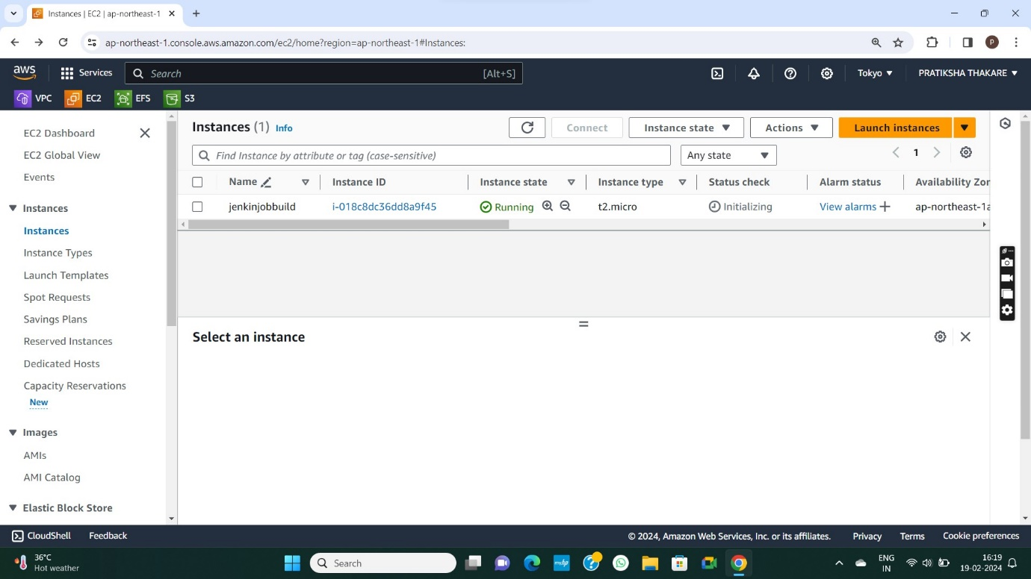

**INSTANCE LAUNCH**

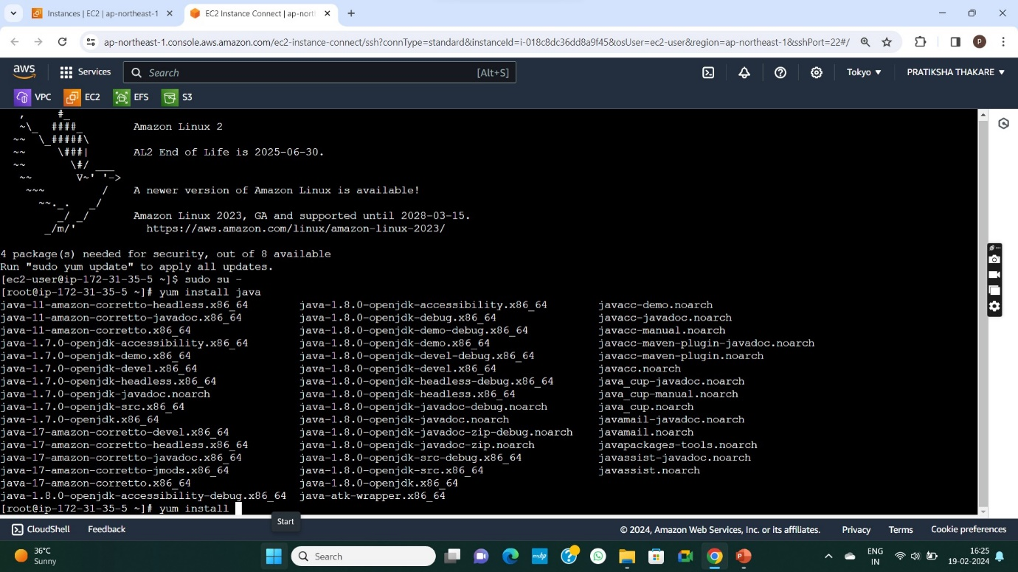

**JAVA -11 INSTALL**

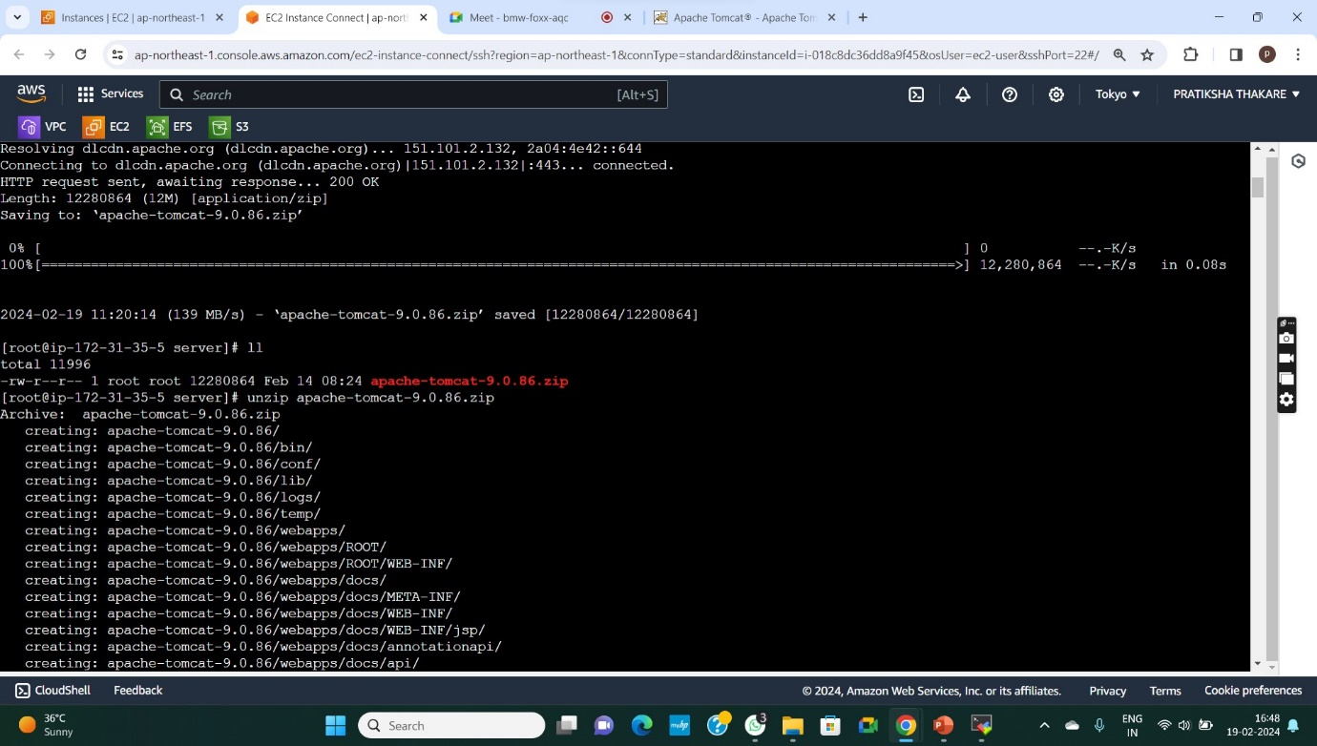

**APACHE TOMCAT INSTALL AND UNZIP FILE**

**FULL PERMISSION TO FILE**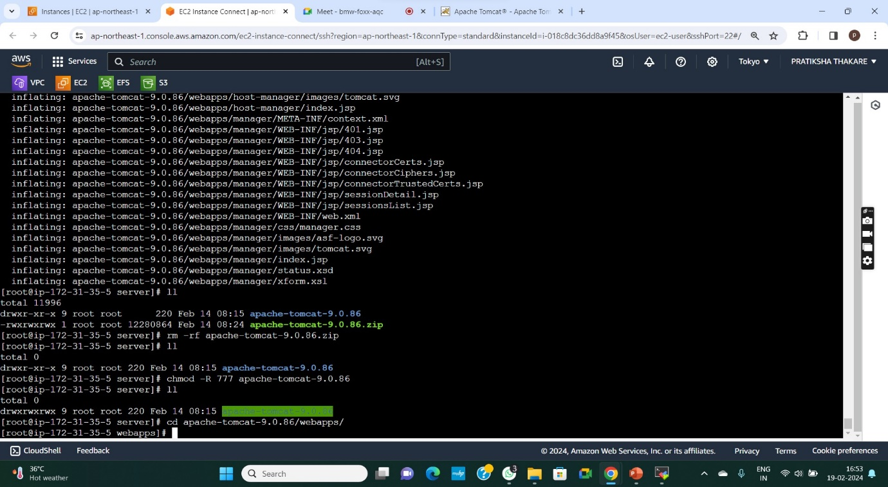

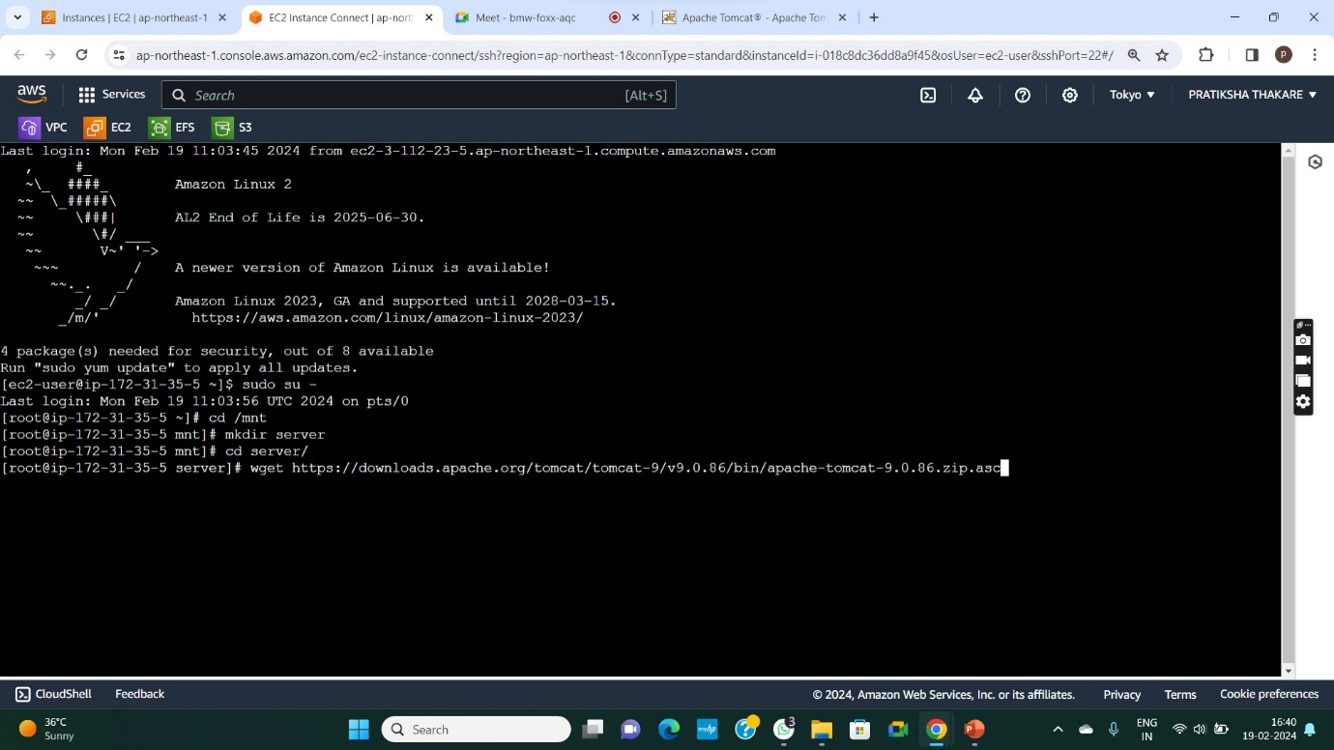

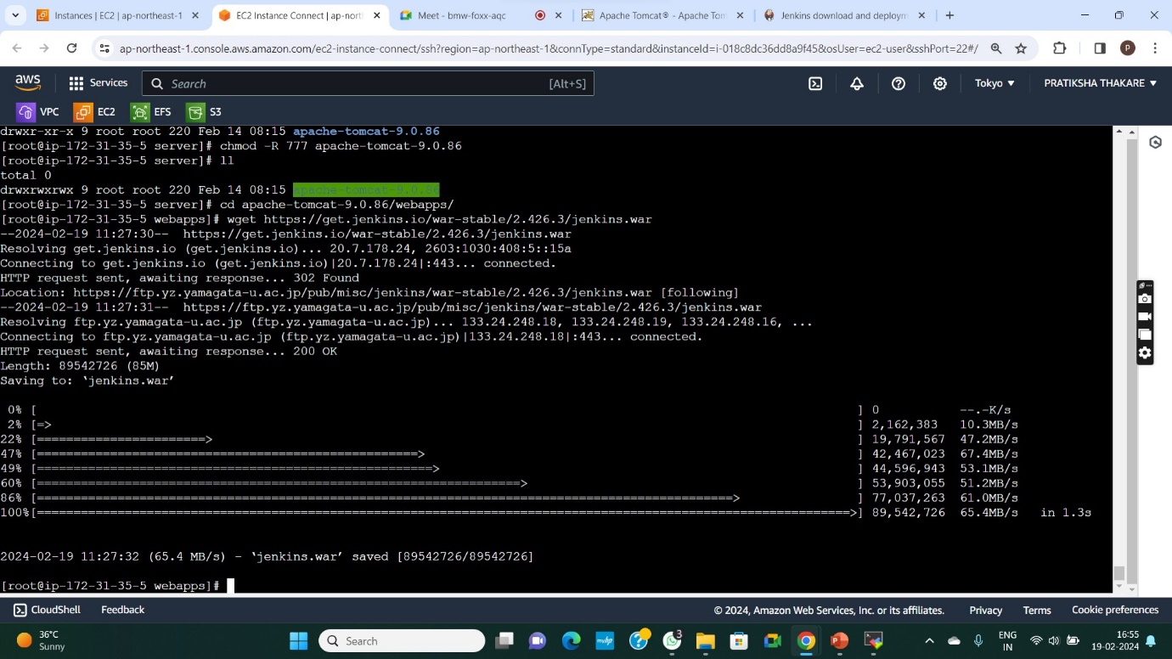

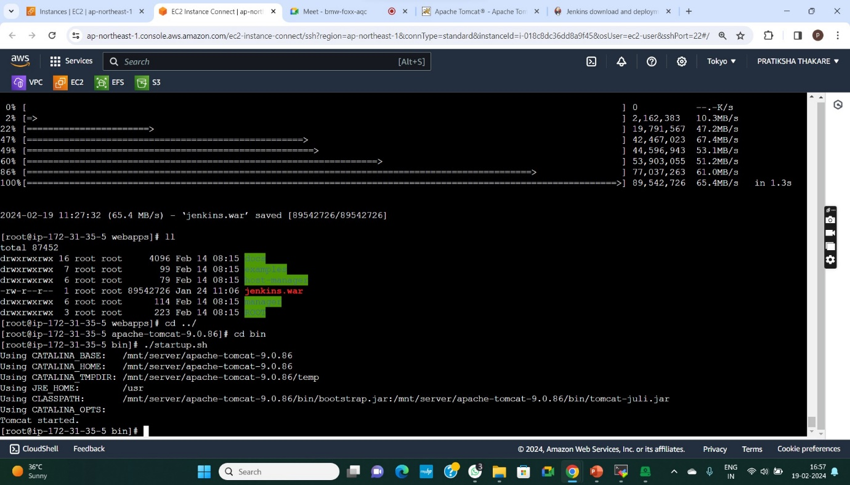

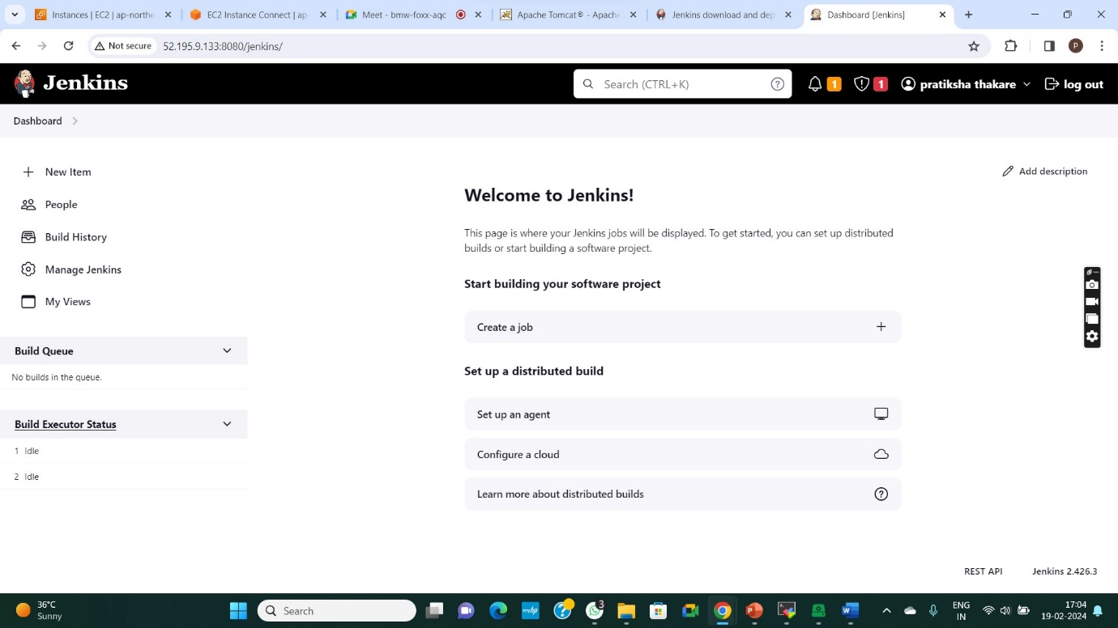

**Jenkis dashboard**

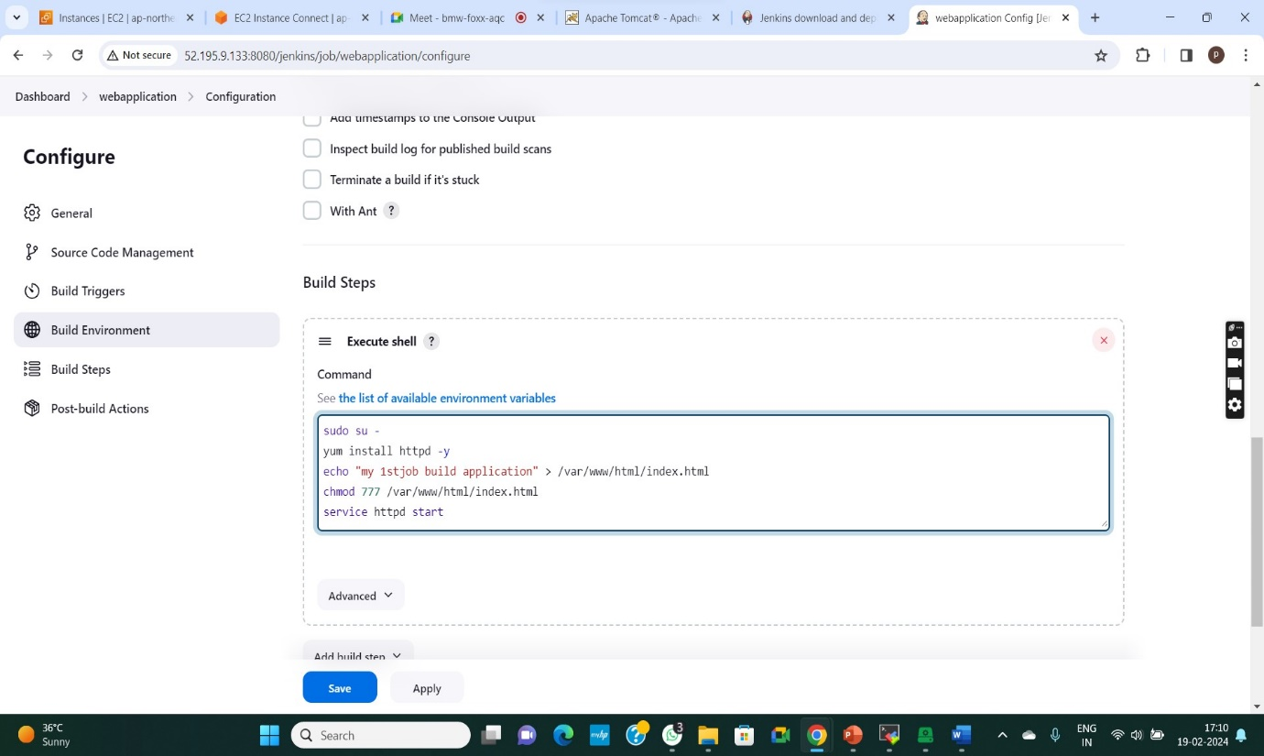

**Build job and httpd service start in index.html**

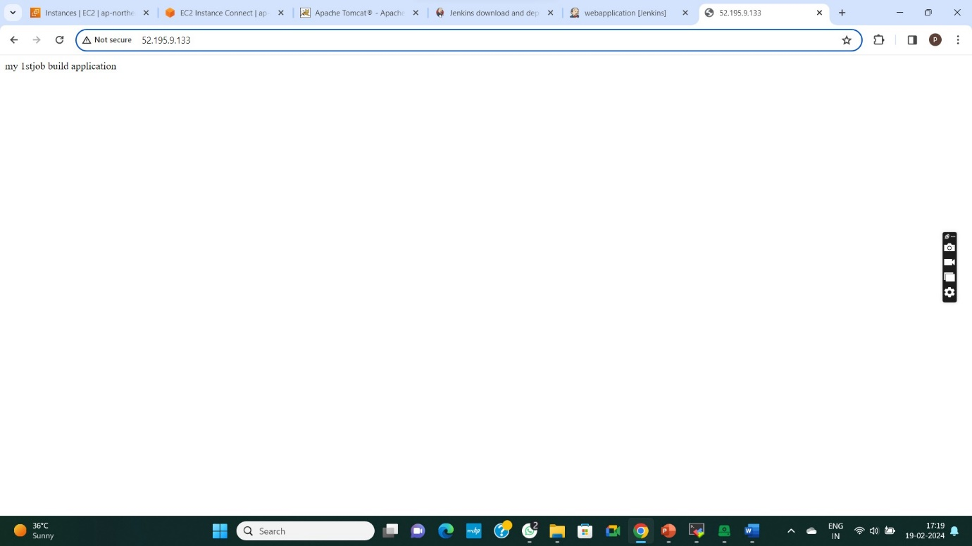

**Access mybuild application**